****MBTI 16-Personality Quiz Game using Java****

## ****Objective:**** To develop a Java-based console application that simulates the Myers-Briggs Type Indicator (MBTI) personality quiz. The goal is to determine the user's personality type based on responses to 15 carefully crafted psychological questions.

## ****Overview:**** This project implements a simplified version of the MBTI (Myers-Briggs Type Indicator), a widely used personality assessment model. The quiz asks the user 15 multiple-choice questions designed to assess preferences across four dichotomies:

1. **Extraversion (E) / Introversion (I)**
2. **Sensing (S) / Intuition (N)**
3. **Thinking (T) / Feeling (F)**
4. **Judging (J) / Perceiving (P)**

Based on the user’s answers, the application calculates and displays their 4-letter personality type (e.g., **INTJ**, **ESFP**, etc.) and shows a short description of the type.

## ****Key Features:****

## ****Interactive Console Interface:**** Simple, clean input prompts using Java’s Scanner class.

## ****Real MBTI Logic:**** Uses four trait axes to determine the user's personality.

## ****Trait Analysis:**** Tallies responses to determine dominant preferences.

## ****Personality Descriptions:**** Displays brief summaries for all 16 MBTI types.

## ****Input Validation:**** Handles incorrect answers gracefully by skipping them.

## ****Technologies Used:****

| Technology | Description |
| --- | --- |
| Java (JDK 17) | Core programming language |
| IntelliJ / VS Code | Development environment |
| Console I/O | User interaction via CLI |
| Java Control Flow | Loops, conditionals, methods |

**Sample Code:**

## import java.util.Scanner;

## public class MBTIPersonalityQuiz {

## // MBTI trait counters

## static int E = 0, I = 0;

## static int S = 0, N = 0;

## static int T = 0, F = 0;

## static int J = 0, P = 0;

## public static void main(String[] args) {

## Scanner scanner = new Scanner(System.in);

## System.out.println("===== MBTI 16 Personality Quiz =====");

## System.out.println("Answer the following 15 questions honestly.\nType 'a' to agree or 'b' to disagree.\n");

## // Questions for each trait

## askQuestion(scanner, "You enjoy vibrant social events with lots of people.", 'E', 'I');

## askQuestion(scanner, "You often spend time exploring unrealistic yet intriguing ideas.", 'N', 'S');

## askQuestion(scanner, "You rely more on logic than emotions when making decisions.", 'T', 'F');

## askQuestion(scanner, "You prefer to have a detailed plan than be spontaneous.", 'J', 'P');

## askQuestion(scanner, "You feel comfortable in large groups of people.", 'E', 'I');

## askQuestion(scanner, "You focus more on the reality of how things are than imagining how they could be.", 'S', 'N');

## askQuestion(scanner, "You think being rational is more important than being compassionate.", 'T', 'F');

## askQuestion(scanner, "You like having things decided rather than going with the flow.", 'J', 'P');

## askQuestion(scanner, "You find it easy to approach strangers and start a conversation.", 'E', 'I');

## askQuestion(scanner, "You are more interested in abstract theories than real-world examples.", 'N', 'S');

## askQuestion(scanner, "You make decisions with your head rather than your heart.", 'T', 'F');

## askQuestion(scanner, "You prefer to stick to a schedule.", 'J', 'P');

## askQuestion(scanner, "You gain energy from social interactions.", 'E', 'I');

## askQuestion(scanner, "You prefer to rely on experience rather than intuition.", 'S', 'N');

## askQuestion(scanner, "You tend to follow your emotions more than logic.", 'F', 'T');

## // Determine final MBTI type

## String mbtiType = "" +

## (E >= I ? "E" : "I") +

## (S >= N ? "S" : "N") +

## (T >= F ? "T" : "F") +

## (J >= P ? "J" : "P");

## System.out.println("\nYour MBTI Personality Type is: " + mbtiType);

## printPersonalityDescription(mbtiType);

## scanner.close();

## }

## // Ask a single question

## static void askQuestion(Scanner scanner, String question, char traitA, char traitB) {

## System.out.println(question);

## System.out.println("a) Agree");

## System.out.println("b) Disagree");

## System.out.print("Your answer (a/b): ");

## char answer = scanner.next().toLowerCase().charAt(0);

## if (answer == 'a') {

## incrementTrait(traitA);

## } else if (answer == 'b') {

## incrementTrait(traitB);

## } else {

## System.out.println("Invalid input. Skipping question.");

## }

## System.out.println();

## }

## // Update trait counters

## static void incrementTrait(char trait) {

## switch (trait) {

## case 'E': E++; break;

## case 'I': I++; break;

## case 'S': S++; break;

## case 'N': N++; break;

## case 'T': T++; break;

## case 'F': F++; break;

## case 'J': J++; break;

## case 'P': P++; break;

## }

## }

## // Print basic personality description

## static void printPersonalityDescription(String type) {

## System.out.println("Description for type " + type + ":");

## switch (type) {

## case "INTJ":

## System.out.println("The Architect: Strategic, logical, and independent thinkers.");

## break;

## case "ENTP":

## System.out.println("The Debater: Energetic, creative, and curious problem-solvers.");

## break;

## case "INFJ":

## System.out.println("The Advocate: Quiet and idealistic visionaries.");

## break;

## case "ENFP":

## System.out.println("The Campaigner: Enthusiastic, imaginative, and free-spirited.");

## break;

## case "ISTJ":

## System.out.println("The Logistician: Practical, reliable, and fact-minded.");

## break;

## case "ISFJ":

## System.out.println("The Defender: Protective, warm, and responsible.");

## break;

## case "ESTJ":

## System.out.println("The Executive: Organized, loyal, and value tradition.");

## break;

## case "ESFJ":

## System.out.println("The Consul: Caring, social, and eager to help.");

## break;

## case "INTP":

## System.out.println("The Logician: Inventive, analytical, and quiet thinkers.");

## break;

## case "ENTJ":

## System.out.println("The Commander: Confident, bold, and strategic leaders.");

## break;

## case "INFP":

## System.out.println("The Mediator: Reflective, creative, and deeply empathetic.");

## break;

## case "ENFJ":

## System.out.println("The Protagonist: Charismatic, altruistic, and inspiring leaders.");

## break;

## case "ISTP":

## System.out.println("The Virtuoso: Bold, practical, and hands-on problem solvers.");

## break;

## case "ISFP":

## System.out.println("The Adventurer: Artistic, spontaneous, and quiet.");

## break;

## case "ESTP":

## System.out.println("The Entrepreneur: Energetic, outgoing, and risk-takers.");

## break;

## case "ESFP":

## System.out.println("The Entertainer: Fun-loving, enthusiastic, and people-focused.");

## break;

## default:

## System.out.println("Unknown type. You might be truly unique!");

## }

## }

## }

## ****Sample Output:****

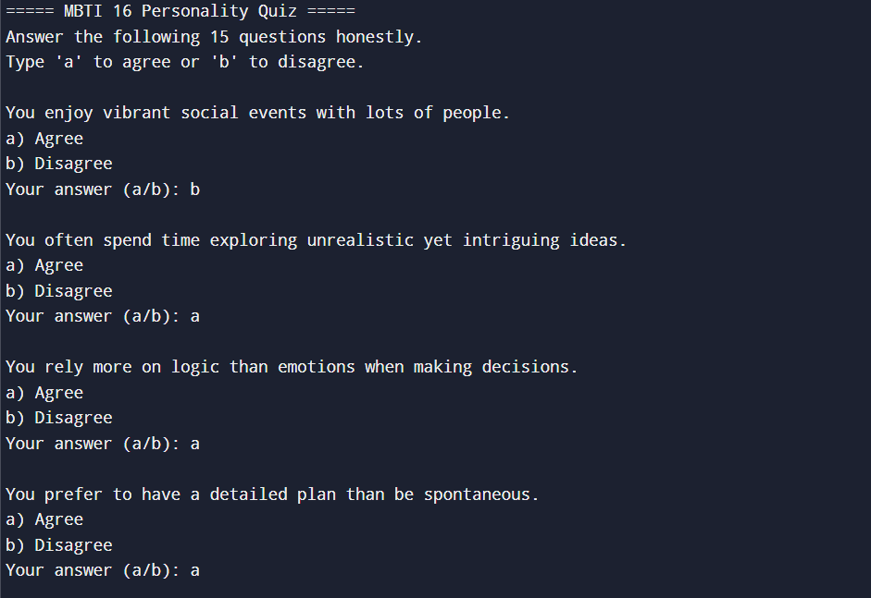

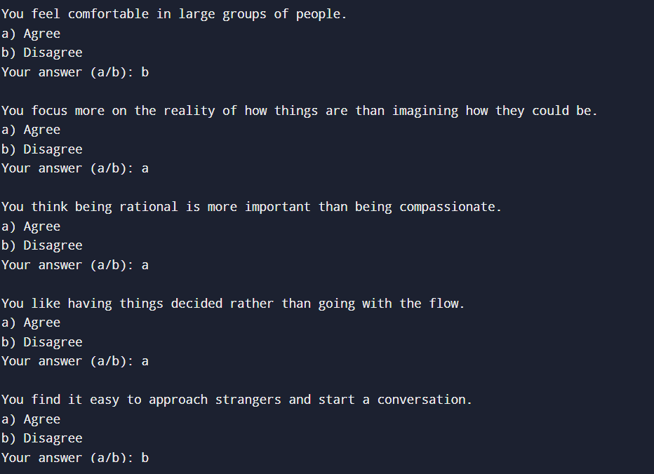

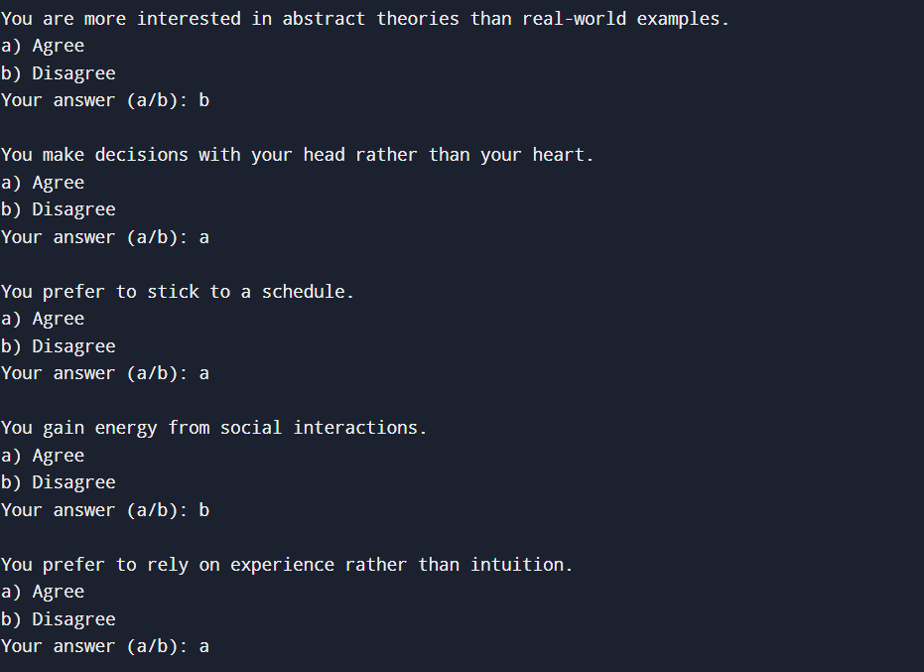

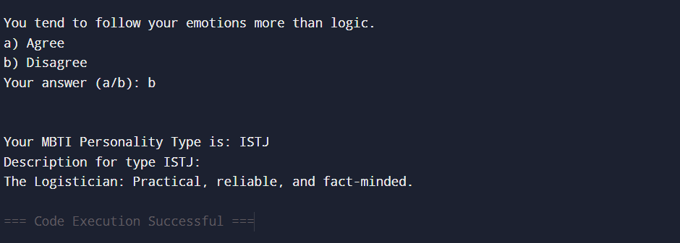

## ****Future Enhancements:****

* GUI version using **Java Swing or JavaFX**.
* Store user results in a **file or database**.
* Add **progress bar** or **graphical summary** of traits.
* Include **PDF export** of quiz results and personality report.
* Load questions from an external **JSON or XML** file for flexibility.